**Jelly Wah Wah**

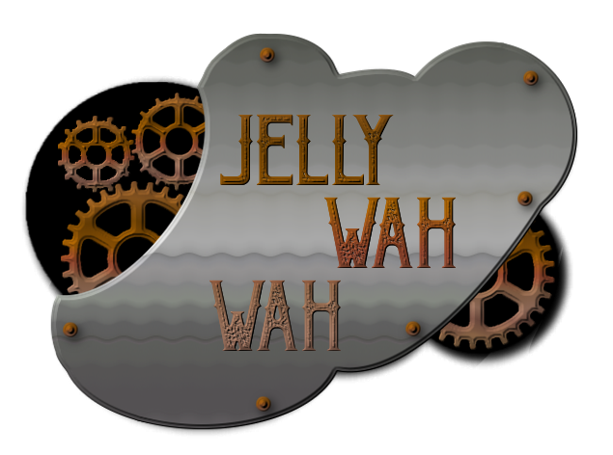

**Design Doc For:**

**One Man Gang**

Written by Aoife Powders, Eoin Abbey-Maher, John Foley

Alex O’Toole

**Design History**

This is the design history of our game.

**Version 1.0**

Version 1.0 we started to design the game.

* We've have some work on the document started.
* We have a game concept.

**Version 2.0**

Added much more to the document.

* Added “The Game World”.
* Added “Game Characters”.
* Added “World Layout”.
* Added pictures of all of the above.
* Added “Feature Set”.
* Added “Common Questions”.
* Added “Story”.

**Version 3.0**

Much more detail than 2.0

* More detailed descriptions of all headings.
* Added “Weapons”.
* Added “User Interface”.
* Added “Music”.
* Added “Rendering System”.
* Added “Game Engine”.
* Added “Camera”.

**Version 4.0**

Small changes on 3.0

* Revision of entire document.

**Game Overview**

**Philosophy**

**Philosophical point #1**

This game will not be a traditional Shoot em up game. It is our unique version of a shoot em up that includes platformer like style as well as the fast pace shoot em up gameplay.

**Philosophical point #2**

Our game will only run on windows pc with a controller, because a controller is an easy way to control shoot em ups.

**Philosophical point #3**

Our goal is to combine platformers and shoot em ups to make a new unique shoot em up game.

**Story**

You play a man who formed a gang that consists of himself only. He Starts a turf war with the other gang in the area and war breaks out. You have to brutally murder all the gang members to save yourself.

**Common Questions**

**What is the game?**

We are working on a unique version of a shoot em up that combines traditional shoot em up games and platform games.

**Why Create This Game?**

We have decided to create this game because we haven't found many games that combine shoot em ups and platformer games.

**Where does the game take place?**

The game takes place on the characters journey to defeat the gangs of new york in the the 1920s.

**What do I control?**

You control a gang member who is the only member of his gang.

**How many characters do I control?**

One.

**What is the main focus?**

The main focus is to kill as many gang members as possible in each wave.

**What's different?**

We have combined platformers and shoot em ups to creates a unique game that we haven't seen much of yet.

**Feature Set**

**General Features**

2D Graphics

**Gameplay**

Waves of enemies to brutally murder

Epic music

Shooting sound effects

Unique and beautiful background

Super fun shooting mechanics

Awesome power ups

Cool animations

Platforms.

Lots of blood

Particles

Different guns

Different bullet types

**The Game World**

**Overview**

2D

Old style new york in the background

Atmospheric feel

**World Feature**

Platforms for gaining an advantage on the enemy

Platforms correlate with the background

Boxes to hide behind, boxes change position each wave.

**Key Locations**

The city of new york.

**Travel**

Run

**Objects**

Health Pickups

Gun upgrades

Platforms

Box Obstacles

**Waves**

Waves of enemies on screen , clear a wave to move to the next wave. When all the enemies of a wave are killed the wave number increments and more enemies come back from the sides.

**Rendering System**

**2D Rendering**

SFML -2.4.2

**Camera**

**Overview**

Side scroller style so camera will be beside the character all the times.

**Game Engine**

**Overview**

Visual studios, using SFML -2.4.2

**Collision Detection**

Coded using C++

**Game Characters**

**Overview**

The main character of the game that the player controls is a man who is fighting an epic battle against the gangs of new york.

**Enemies and Monsters**

The enemies are all gang members.

**User Interface**

**Overview**

There is a small amount of UI on the screen while playing.

On the billboard in the background is what wave you are on and how many enemies have been killed

The health bar and timer for how long the gun power ups last is on the HUD located on the top of the billboard.

**Weapons**

**Overview**

The gun is modelled as a Tommygun. There will be 3 power-ups dropped at the top of the screen Which change the type of bullet that the gun shoots and the gun model.

The bullet types include

* Normal
* Buckshot
* MultiShot

Each bullet type has a different reload time and can kill more enemies.For example the multishot can kill 6 enemies and the normal can only kill one.

**Musical Scores and Sound Effects**

**Overview**

LMMS was used to make the music in the game.

Audacity was used to make sound effects.